

**Department of CSE**

**CSE209 Lab**

**Course Name: Electrical Circuits**

**Course Code: CSE209**

**Section No: 2**

**Experiment No: 03**

**Name of the Experiment:** Bias Point Detail Analysis of DC Circuit with Independent Sources Using PSpice Schematics.

**Date of submission: 07/09/21**

Student’s Name: Md Abdul Ahad Rifat

Student’s ID: 2020-1-60-215

**Submitted to**

Rashedul Amin Tuhin

Senior Lecturer

Department of Computer Science and Engineering

East West University

**Objectives:**

1. To learn fundamentals of PSpice.

2. To analyze Bias Point Detail of DC circuit using PSpice Schematics.

**Circuit Diagram(s):**

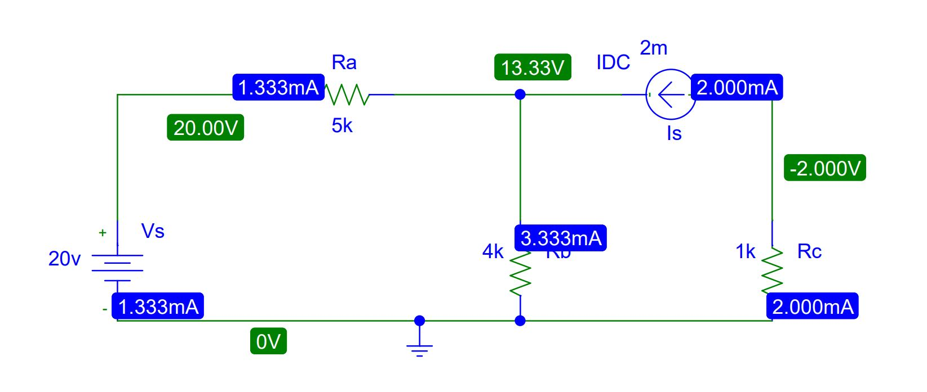

**Figure 1.Circuit Diagram for Experiment 3**

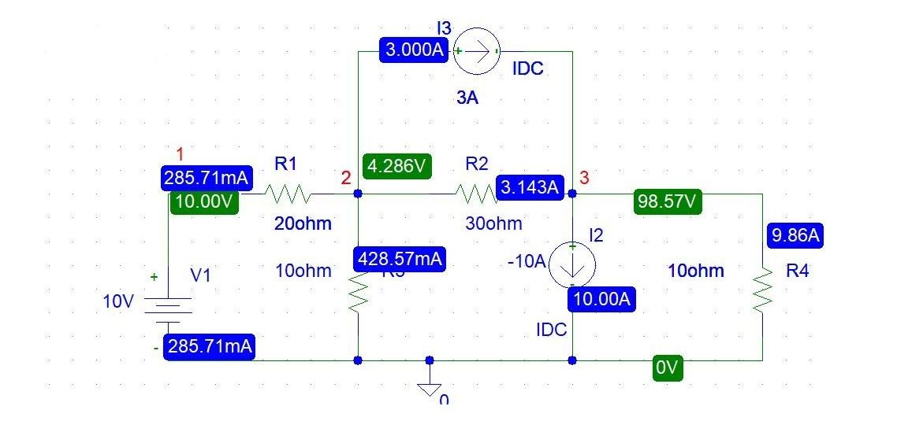

**Figure 2.Circuit Diagram for Experiment 3**

**Post-Lab Report Questions and Answers:**

1. Theoretically calculate all the currents and the voltages for the circuit shown in Figure 2.

**Answer:**

Applying KCL at node 2,

$$\frac{10-V_{2}}{20}=3+\frac{V_{2}}{10}+\frac{V_{2}-V_{3}}{30}$$

Applying KCL at node 3,

$$3+\frac{V_{2}-V_{3}}{30}=-10+\frac{V_{3}}{10}$$

Solving equation 1 and 2 we get,

$$V_{1}=10 v$$

$$V_{2}=4.286 v$$

$$V_{3}=98.57 v$$

$$I_{1}=\frac{10-V_{2}}{R_{1}}$$

$$=\frac{10-4.286}{20} A$$

$$I_{1}=258.71 mA$$

$$I_{2}=\frac{V_{2}-V_{3}}{R_{2}}$$

$$=\frac{4.286-98.57}{30} A$$

$$I_{2}=-3.1428A$$

$$I_{3}=\frac{V_{2}-0}{R_{3}}$$

$$=\frac{4.286-0}{10} A$$

$$I_{3}=428.57mA$$

$$I_{4}=\frac{V_{3}-0}{R_{4}}$$

$$=\frac{98.57-0}{10} A$$

$$I_{4}=9.86A$$

1. Compare the theoretical solution of the circuit shown in Figure 2 with the solutions obtained from PSpice.

**Answer:** There has been no change in theoretical calculation value and Pspice simulation value in Figure 2.

**Conclusion:**

In experiment 3 in using PSpice use is nothing new for us. We already know how to use PSpice software since in experiment no 1. In this experiment, we identify the value of Voltage and Current using PSpice simulation software also we theoretically calculate this value using KCL. And there is no discrepancy between the theoretical and simulated value because this is not the actual lab. So this experiment main theme is how to use PSpice software to identify Bias Point Detail of DC circuit using PSpice Schematics.